Elastic Container Service (ECS) Task

- Setup a highly available ecs cluster with load balancer and dynamic port mapping.
NOTE:
Your cluster should maintain atleast 6 tasks at any point of time and should be highly availble across multiple AZ's.
Use the below image from deployment:
sabair0509/hiring-app:works

🔹 Step 1: Create ECS Cluster (EC2 Launch Type)
Service Used:

👉 Amazon ECS

Configuration:

Cluster Name: hiring-app-cluster

Infrastructure: EC2 Linux

Instance Type: t3.medium (example)

Number of Instances: 3

VPC: hiring-app-vpc

Subnets: Default subnets (Multi-AZ)

Auto Scaling Group: Enabled

What Happened Internally:

EC2 instances launched

ECS agent installed

Instances registered to cluster
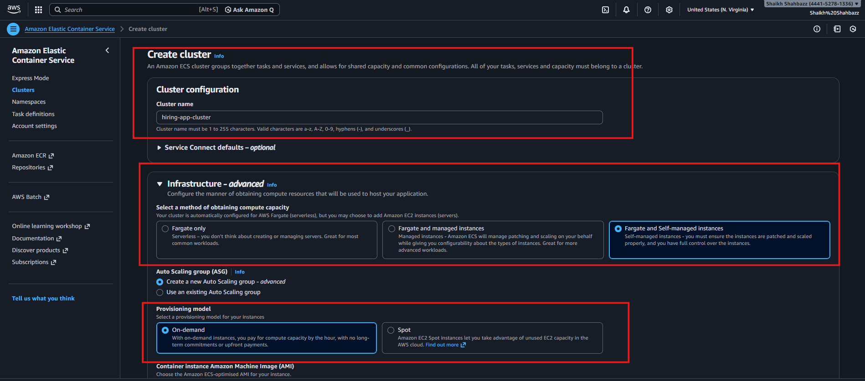
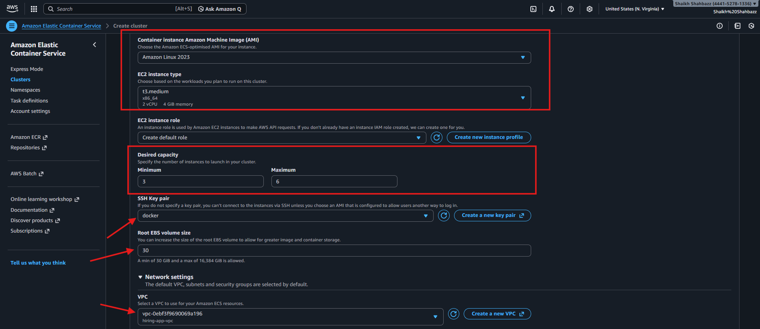
Validation: ECS Cluster created
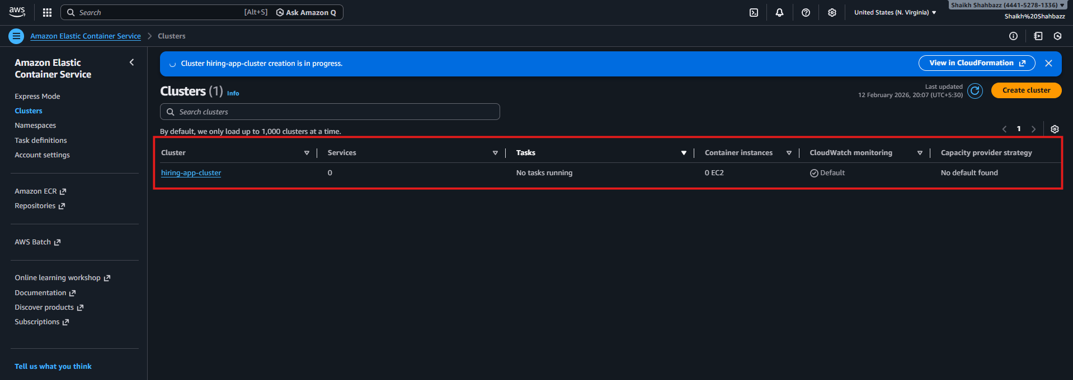

🔹 Step 2: Create Task Definition
Service Used:
ECS → Task Definitions

Configuration:

Launch Type: EC2

Network Mode: bridge (for dynamic port mapping)

Container Settings:
Parameter Value
Image sabair0509/hiring-app:works
Container Port 8080
Host Port 0
Protocol HTTP
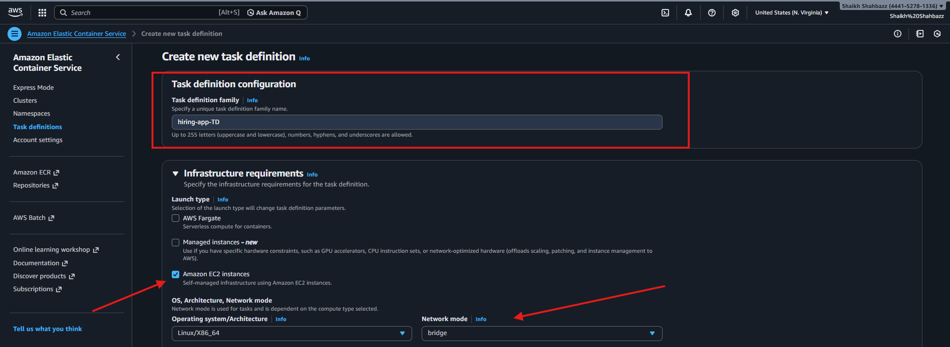
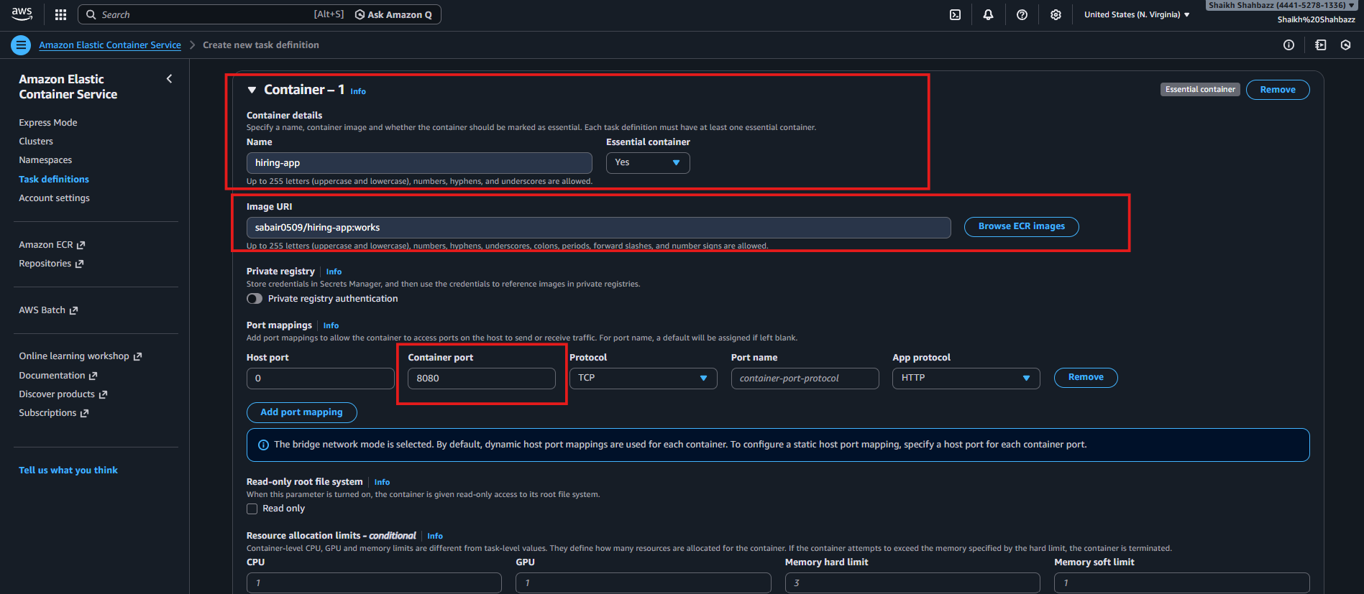
Why Host Port 0?
Enables dynamic port allocation
Prevents port conflicts
Allows multiple tasks per EC2

🔹 Step 3: Create Application Load Balancer
Service Used:
Validation: Task Definition created
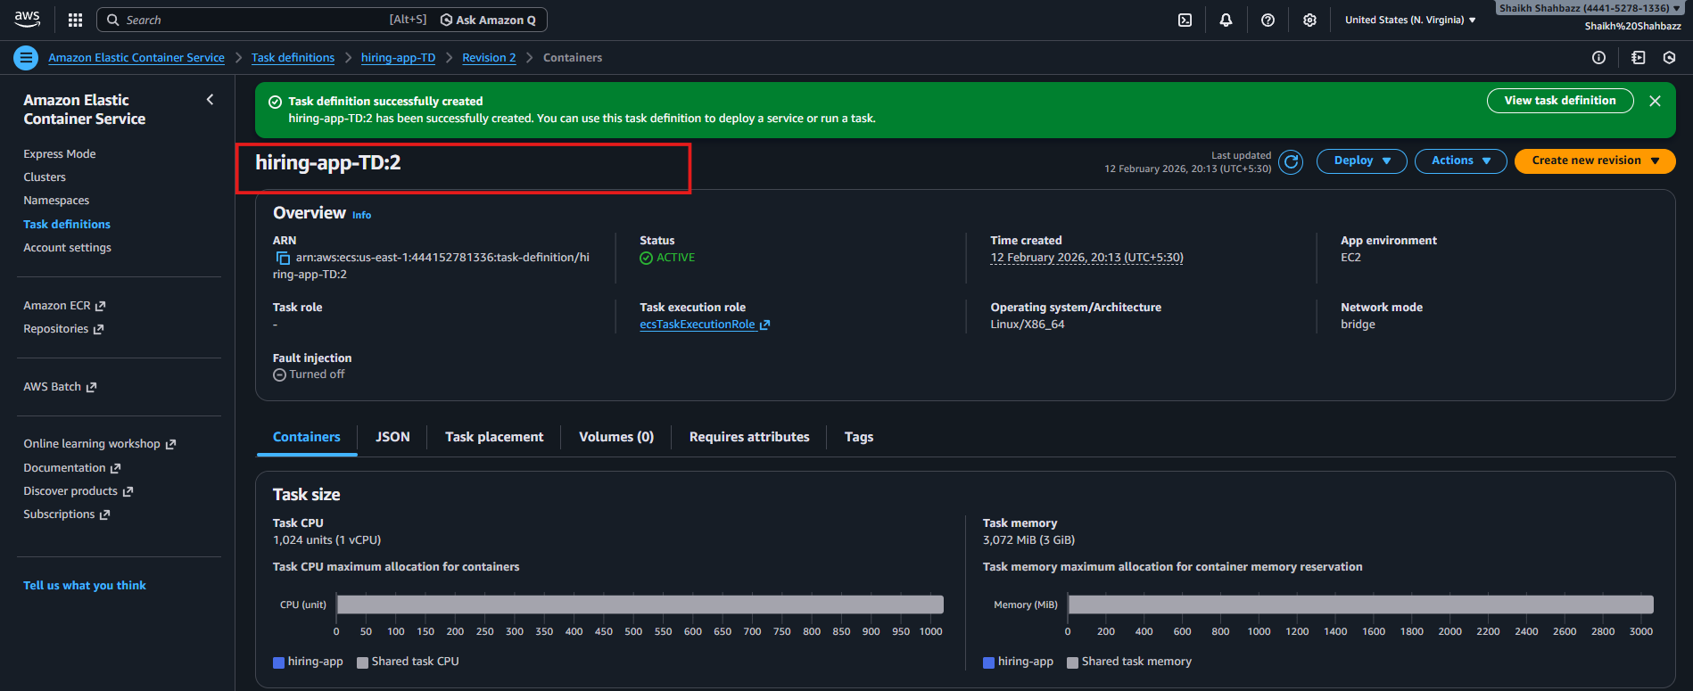

EC2 → Load Balancer

Configuration:
Type: Application Load Balancer
Scheme: Internet-facing
VPC: Default
Subnets: At least 2 AZs
Listener: HTTP 80
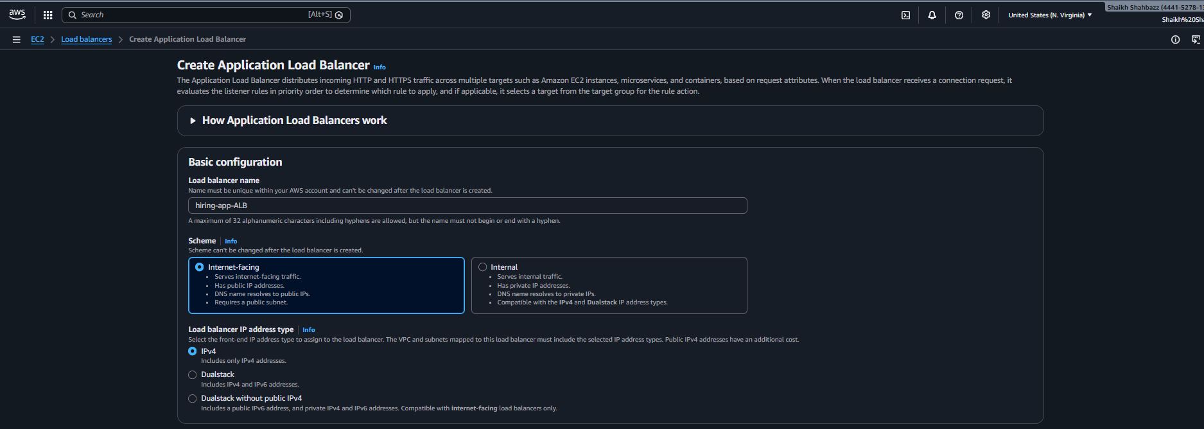
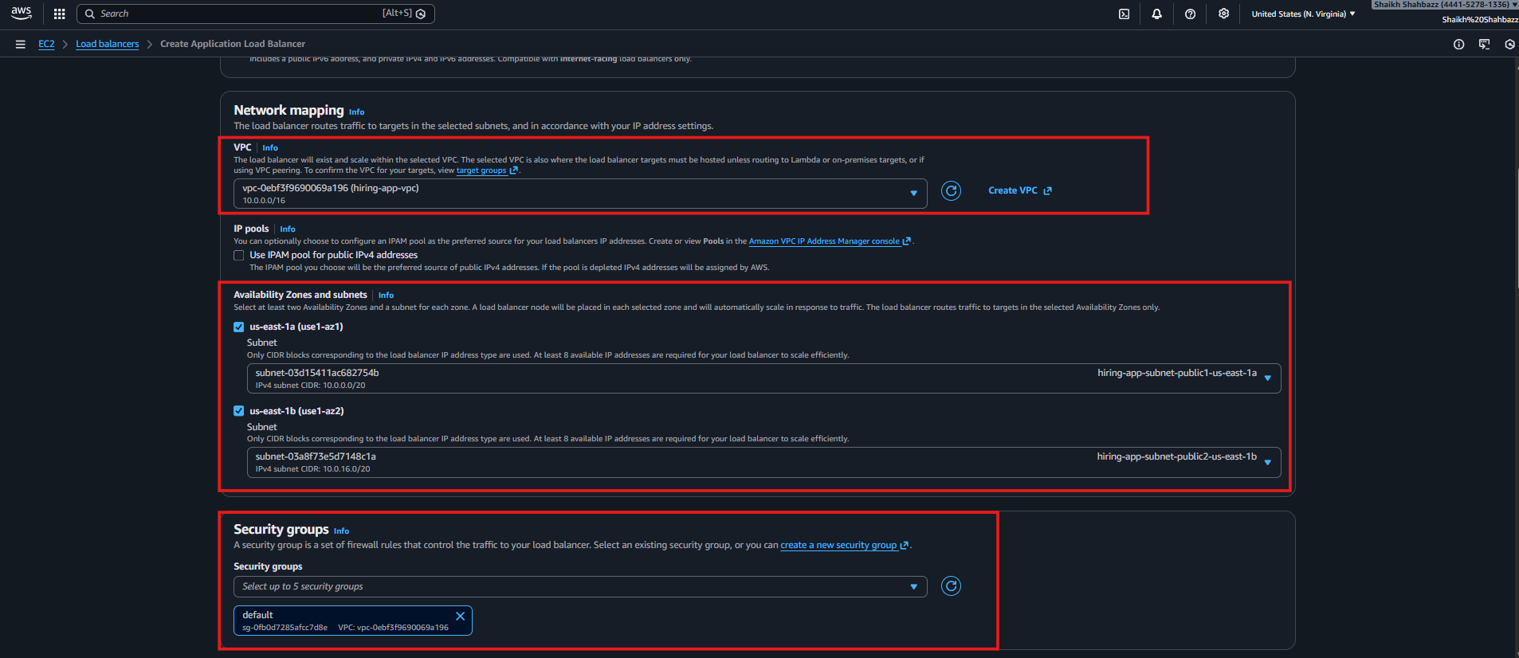
Validation: Application Load Balancer is created
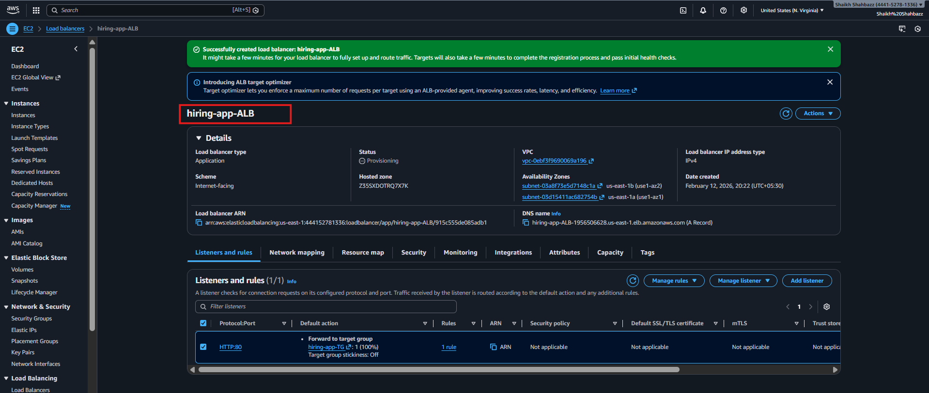

🔹 Step 4: Create Target Group
Configuration:
Target Type: Instance
Protocol: HTTP
Port: 8080
Health Check Path: /
VPC: hiring-app-vpc
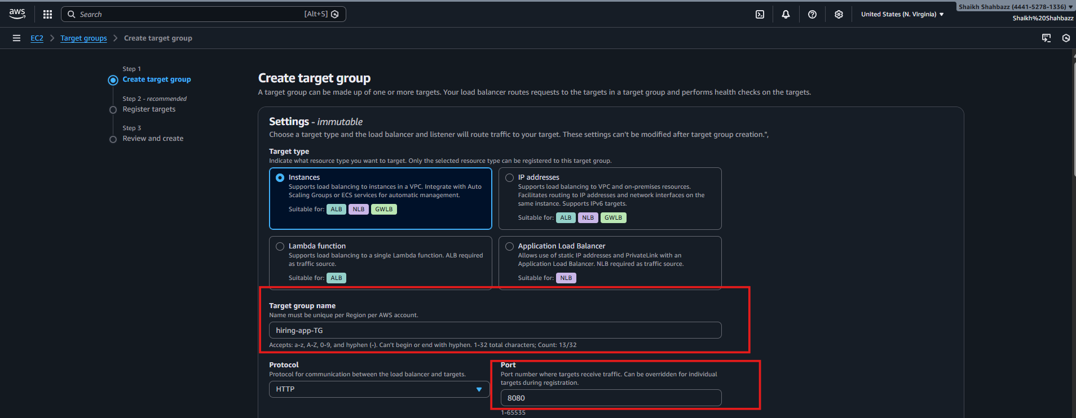
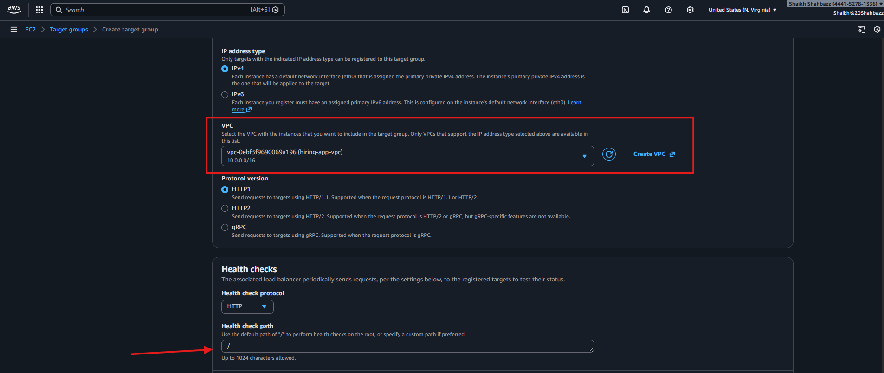
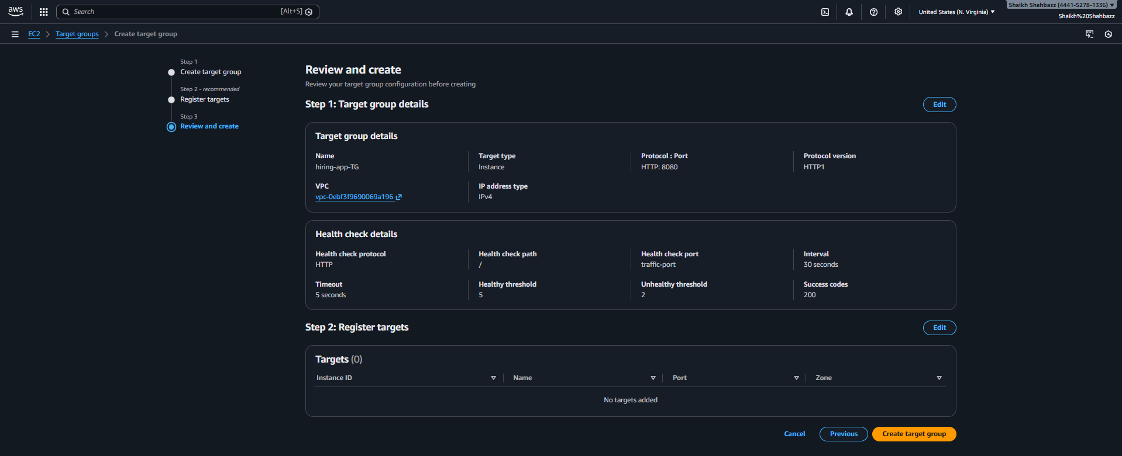

Purpose:
Registers EC2 instance + dynamic port
Performs health checks
Validation: Target Group Created
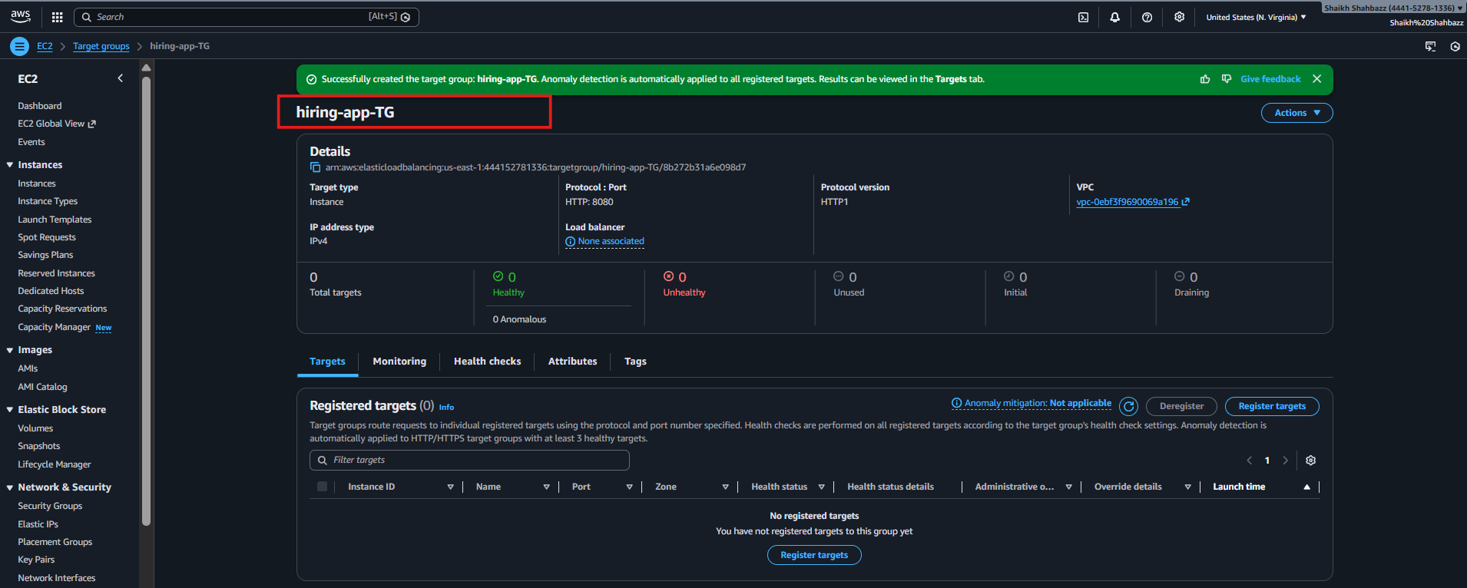

Step 5: Create ECS Service (Main Connecting Step)
Service Used:
ECS → Cluster → Create Service

Configuration:
Setting Value
Launch Type EC2
Task Definition hiring-task
Desired Count 6
Load Balancer Attach existing ALB
Target Group Select created TG
Container Port 8080
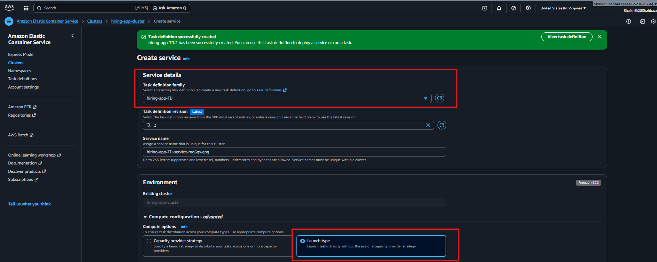
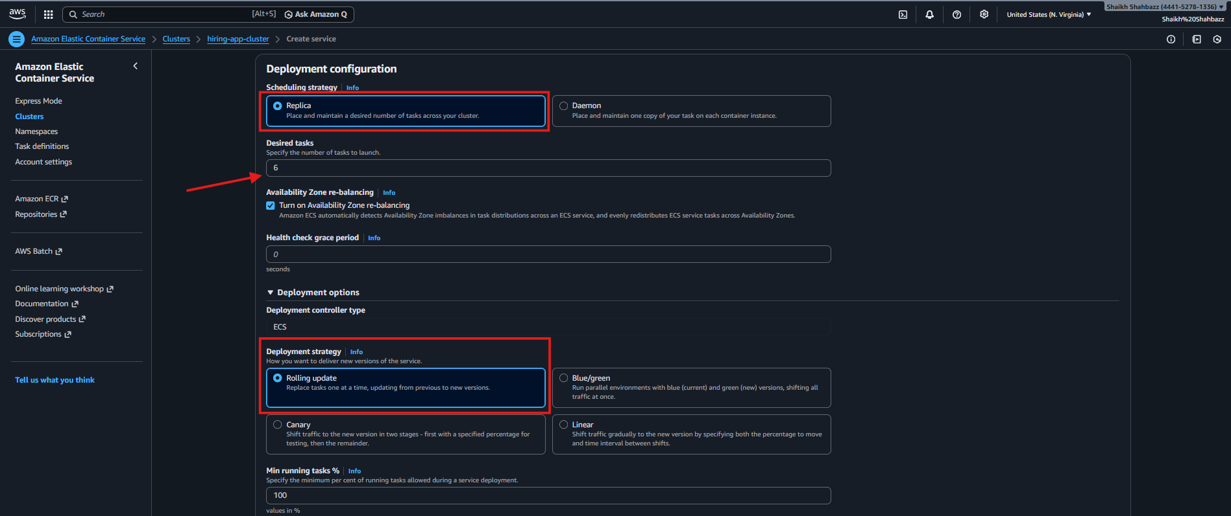

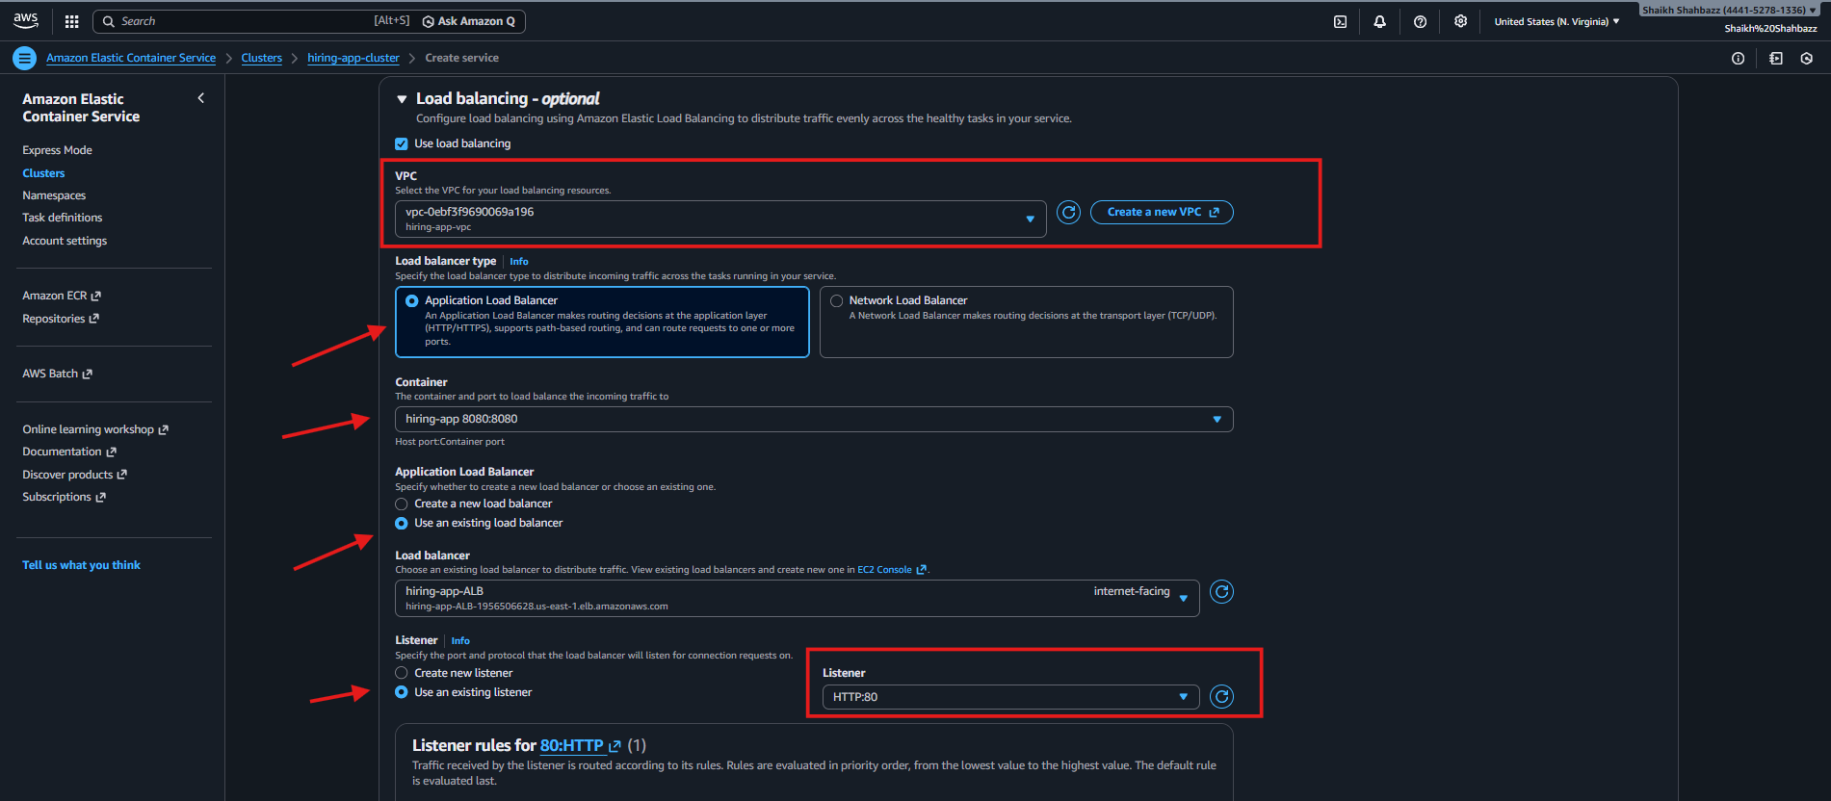
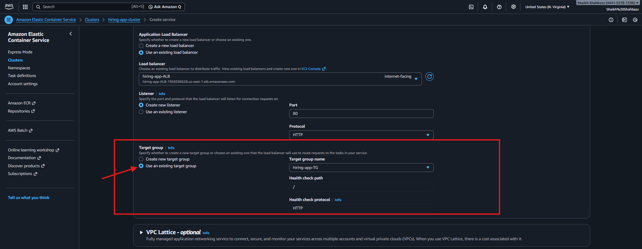
Validation: Naviagate to hiring-app-cluster Service tab
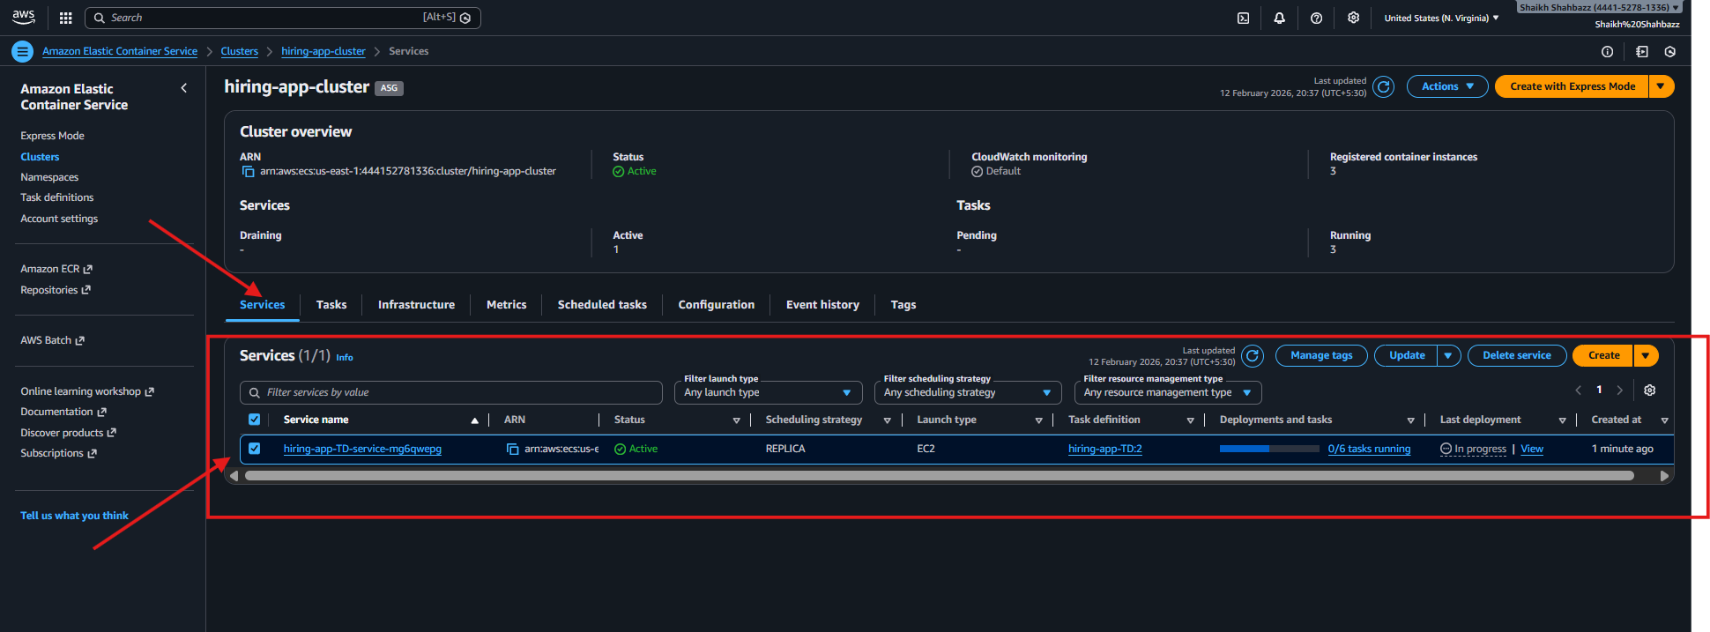
Step 6: High Availability Achieved By
Component HA Mechanism
ALB Multi-AZ
EC2 ASG Multi-AZ
ECS Service Desired count = 6
Health Checks Auto replacement
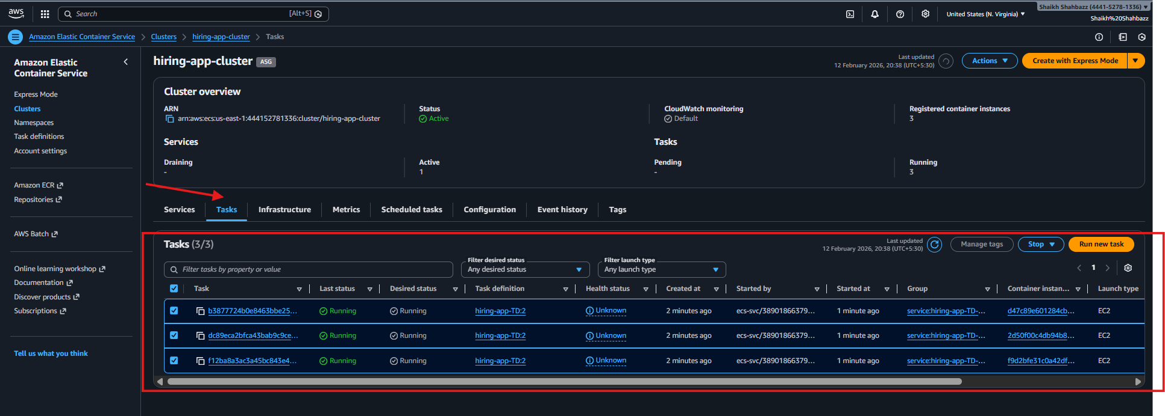
Navigate to S.G of instances from ECS Edit-Inbound Rules Add this < 8080 >
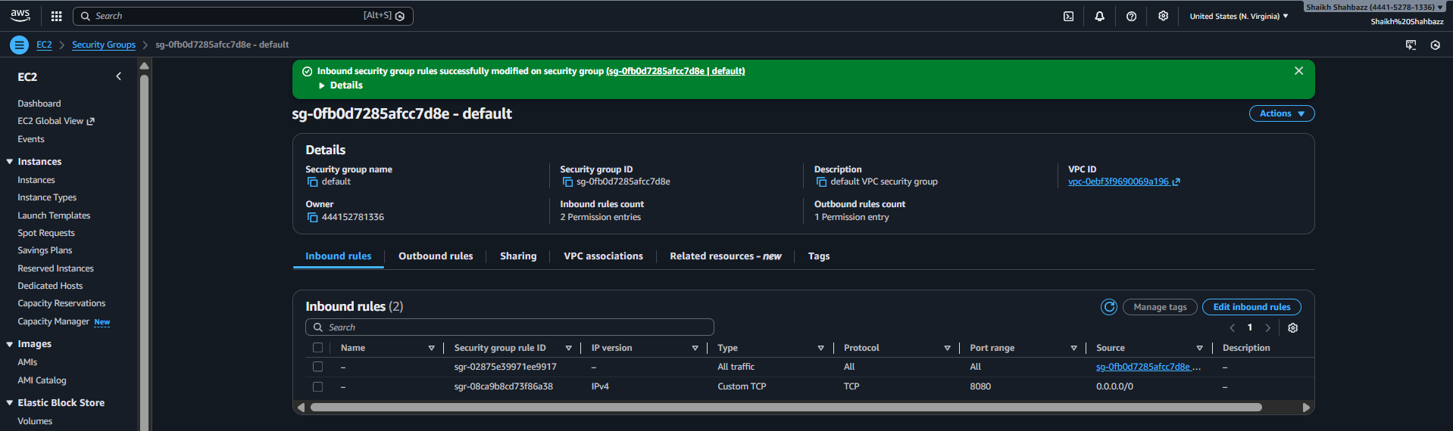

🔹 Step 7: Verification
You checked:
ECS → Running Tasks = 6
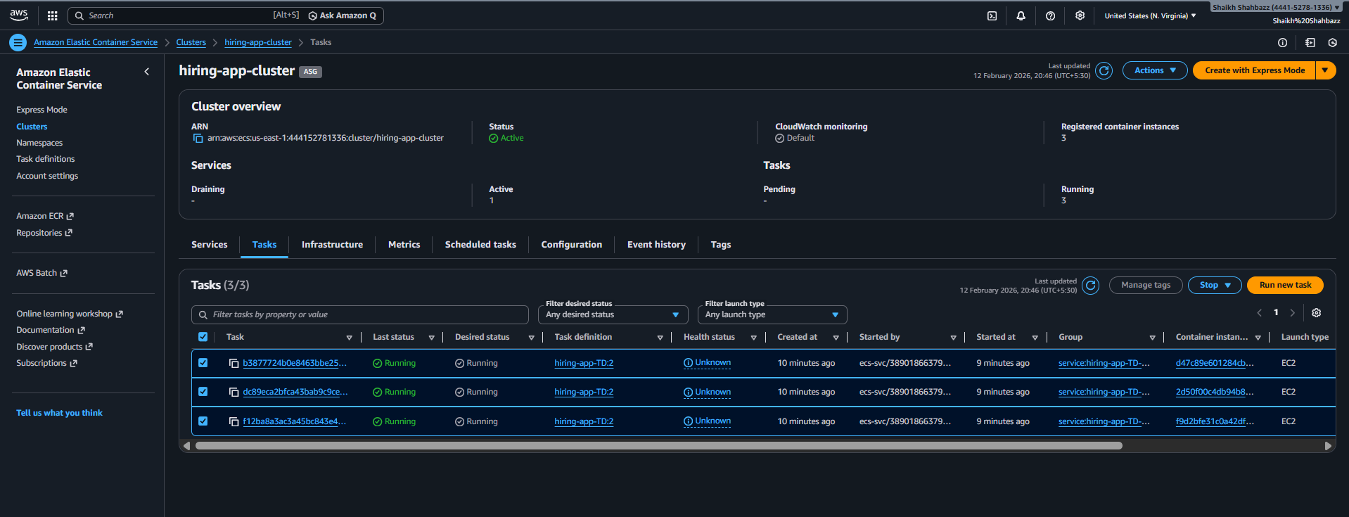
Running 3 Instances
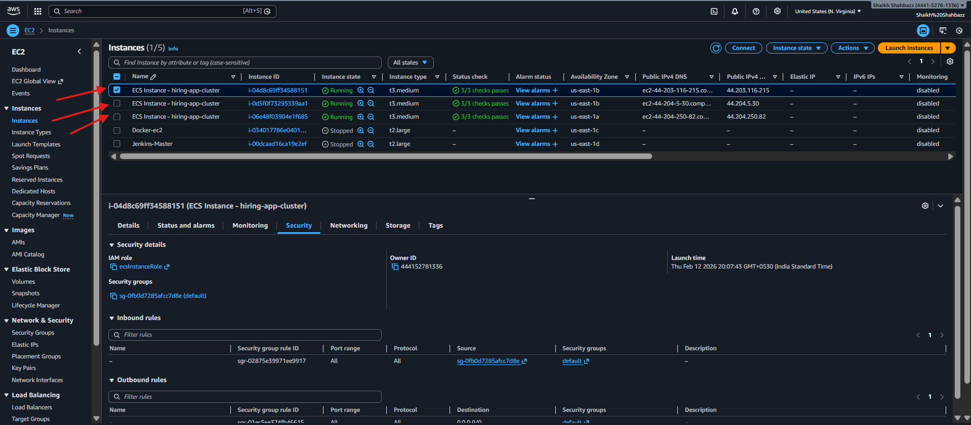
Target Group → Healthy Targets
ALB DNS → Application accessible
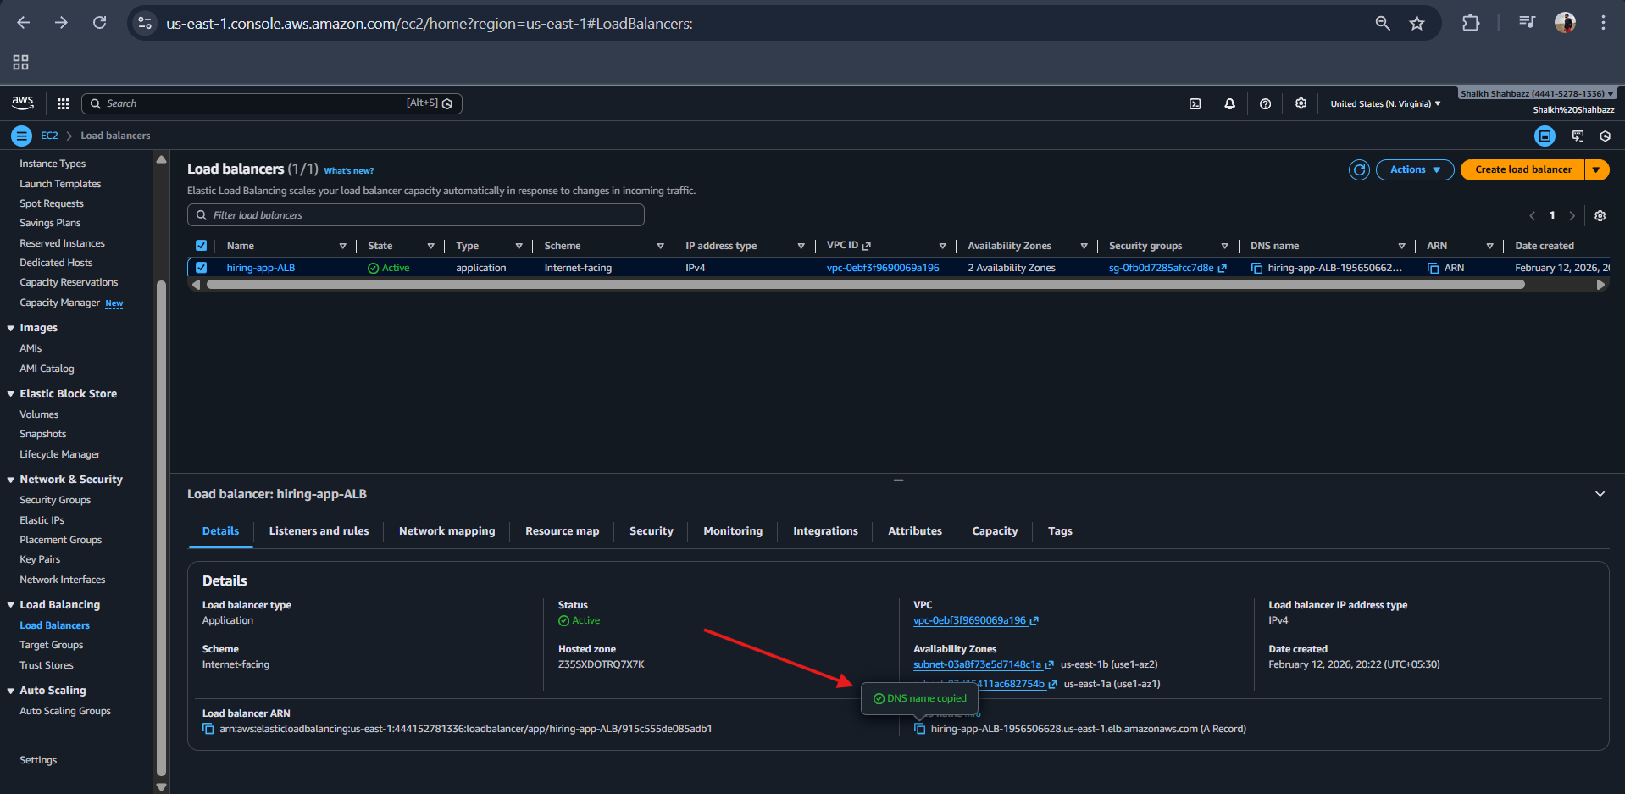
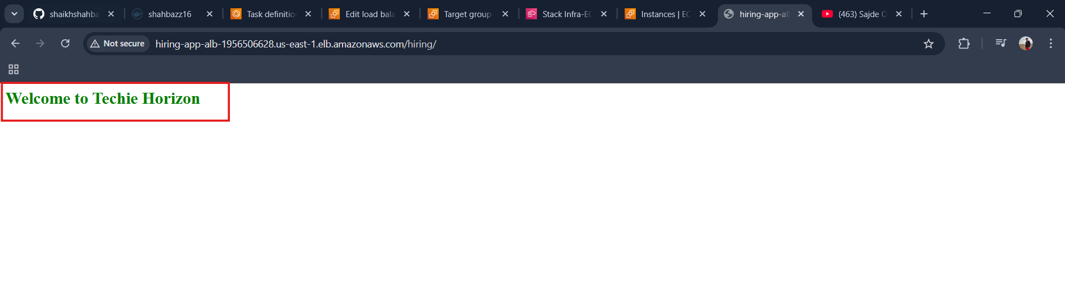
Deployment successful ✅
Validation: http://hiring-app-alb-1956506628.us-east-1.elb.amazonaws.com/hiring/


Complete Flow Summary
Cluster → Provides compute
Task Definition → Defines container
Load Balancer → Handles traffic
Target Group → Registers tasks
Service → Connects everything

